We Need You!

F.I.R.S.T. (For Inspiration & Recognition of Science & Technology) is an organization that is dedicated to “creating a world where science and technology are celebrated” through motivational robotics programs for school- aged children. It is a volunteer driven program that relies on the generous donations of time, talent and resources from individuals and businesses around the world.

The Adventurers Homeschool Association robotics program has been started using substantial fees from student team members, but we strongly hope to be able to offer participation to all who are interested. Making wider participation possible will depend on donations and support from individuals and businesses. FIRST Tech Challenge (FTC) robotics teams for junior high through high school students allow participants to explore and experience science, math and technology careers. In doing this, we help to open doors for these young students and to get them excited about working with math, science and technology. This program allows these children to work on research, project development, model building, programming and teamwork. The life skills that FIRST students learn prepare them for the job market no matter what career path they choose.

Our official challenge will not be released until September; however, we would like to get our teams registered now. This will ensure timely delivery of our kit of parts.

Our team is looking for 2013-2014 sponsors for our rookie team this year. If you sponsor our team, you will be recognized in all of our media releases.

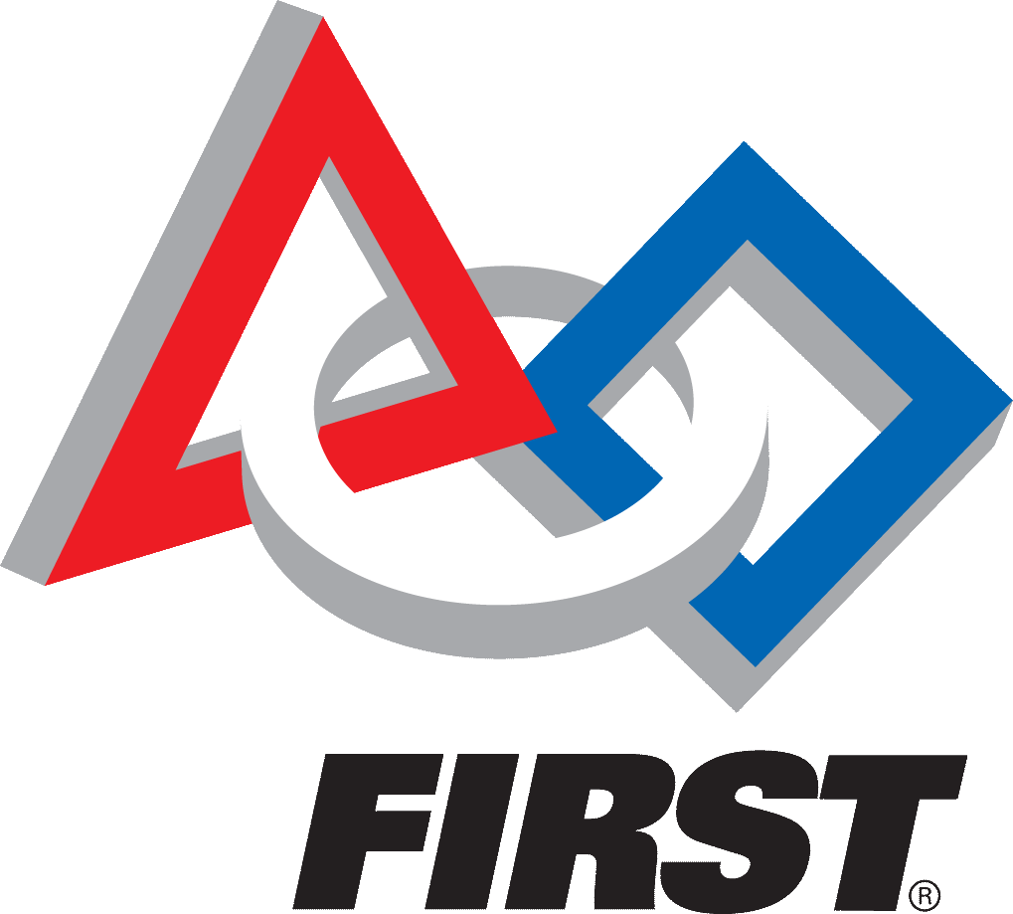Most importantly, your sponsorship will allow our robotics program to get off to a strong start and lay the groundwork for next year. Our team receives no public or government funding, and each student team member has contributed substantially. Your donations will have lasting impacts on future generations. I hope you will consider giving to this worthy program.

For more details, check out the FIRST FTC web site: [www.usfirst.org/roboticsprograms/ftc](http://www.usfirst.org/roboticsprograms/ftc).

Sincerely,

William Boyer  
Adventurers Homeschool Association FTC Robotics Coach

------------------------Please tear off, keep the top for your records and return the bottom to us!------------------------------------

We commit to donating $\_\_\_\_\_\_\_\_\_\_\_\_\_\_\_ to a FTC Team for the 2013-2014 season. We would like our donation to support the following team: Adventurers Homeschool Association FTC Robotics Team

Company Name: \_\_\_\_\_\_\_\_\_\_\_\_\_\_\_\_\_\_\_\_\_\_\_\_\_\_\_\_\_\_\_\_\_\_\_\_\_\_\_\_\_\_\_\_\_\_\_\_\_\_\_\_\_ Phone: \_\_\_\_\_\_\_\_\_\_\_\_\_\_\_\_\_\_\_\_\_ Address: \_\_\_\_\_\_\_\_\_\_\_\_\_\_\_\_\_\_\_\_\_\_\_\_\_\_\_\_\_\_\_\_\_\_\_\_\_\_\_\_\_\_\_\_\_\_\_\_\_\_\_\_\_\_\_\_\_\_\_\_\_\_\_\_ \_\_\_\_\_\_\_\_\_\_\_\_\_\_\_\_\_ City/State/Zip \_\_\_\_\_\_\_\_\_\_\_\_\_\_\_\_\_\_\_\_\_\_\_\_\_\_\_\_\_\_\_\_\_ Contact: \_\_\_\_\_\_\_\_\_\_\_\_\_\_\_\_\_\_\_\_\_\_\_\_\_\_\_\_\_\_\_\_\_\_\_\_\_\_\_\_\_\_\_\_ Email: \_\_\_\_\_\_\_\_\_\_\_\_\_\_\_\_\_\_\_\_\_\_\_\_\_\_\_\_\_\_\_\_\_\_\_\_\_\_\_\_\_\_\_\_\_\_\_\_\_\_\_\_

\*Please make checks payable to **Adventurers Homeschool Association**. We will issue you a tax id donation letter upon receipt of your donation. If you need our tax-id number prior to securing a check, just let us know.

Coach, William Boyer, 6353 Merritt, Ypsilanti, MI 48197; [wslb@wboyer.net](mailto:wslb@wboyer.net) 734-481-3469

|  |  |  |
| --- | --- | --- |
| **DSC04841.JPG** | **JrFLLicon_RGB.gif** | **DSC04841.JPG** |

**Approximate FTC EXPENSES per team:**

Registration $275

Base Kit of Parts $680

Resource Kit of Parts $199

Additional software, hardware required $300 - $500

Tournament Registration $100 - $300

Spirit Buttons, Team shirts, & Trading Items $200

Spare Parts $300 - $500

**Total Cost per team:** **approx. $2,500**

**Inspiring a young child** **PRICELESS**